Data Flow Diagram

Pharmacy Management

System

Ayush Pathak(180352)

Debshsish Bera(180140)

A data flow diagram is a graphical representation or technique depicting information flow and transform that are applied as data moved from input to output. The DFD are partitioned into levels that represent increasing information flow and functional details. The processes, data store, data flow, etc are described in Data Dictionary.

**Data flow:**

Data moves in a specific direction from an origin to destination

**Process:**

Procedure s people or devices that use or transform data

**External entity:**

This defines a source (originator) or destination of system data.

**Data Store:**

This indicates where data is stored in the system.

**2.4.1 Context Diagram**

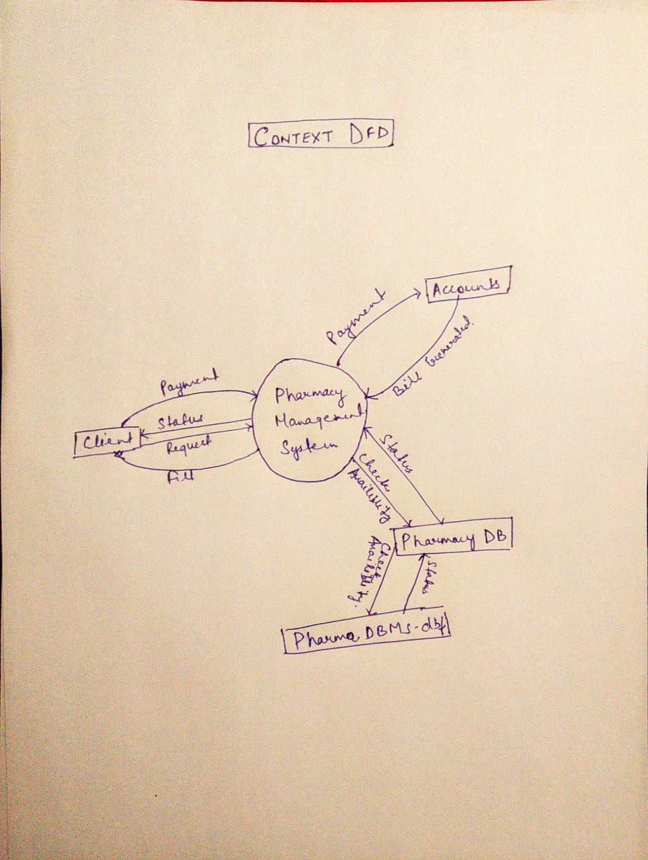

**Fig. 0th Level DFD**

In the 0th level of the DFD the client request the Pharmacy Database process for some product or the medicine than the process gives the check availability signal to the pharmacy Database for the requested product or the medicines availability. After checking the availability, the Database sends the status to the Pharmacy Database process. Then the Pharmacy Database process gives the status to the client and according to the status the client buys the product and pays the bill and the external entity Accounts than generates the bill for the purchased product.

**2.4.2 First Level DFD**

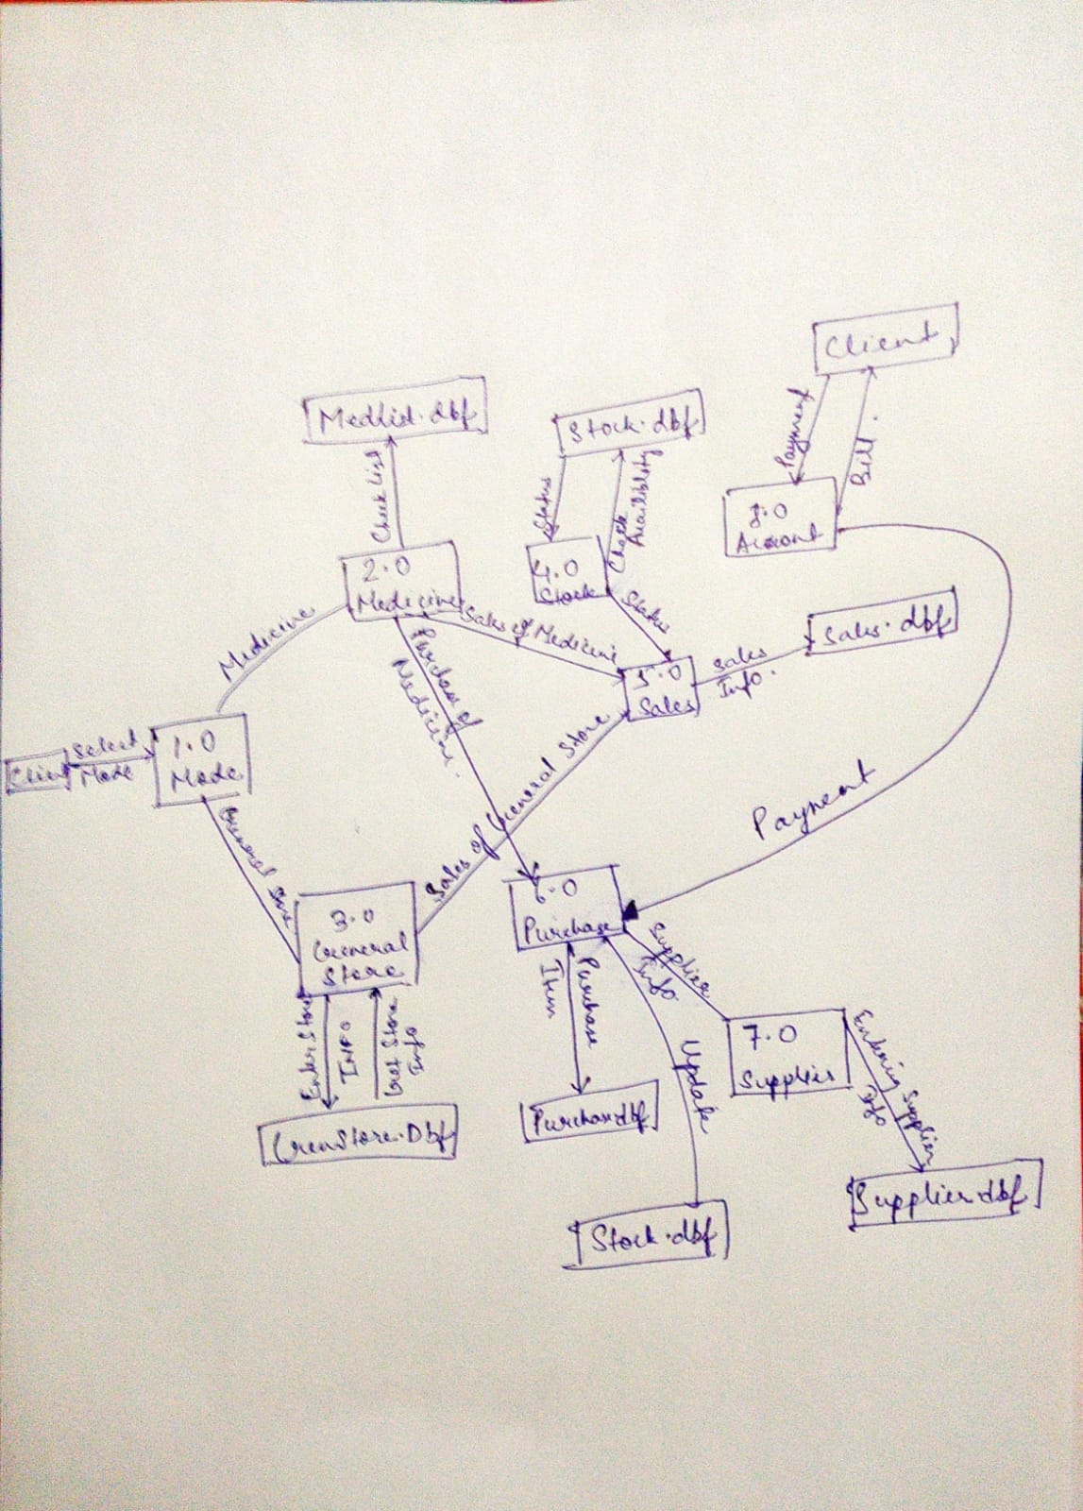

**Fig. 1st Level DFD**

In level one of the DFD the client select the mode of the action i.e. whether he wants to buy a medicine or general store product. If he selects mode as medicine than the flow of data will be as follows:

The process 2.0 i.e. medicine can enter the medicine information into the Database or can retrieve the information from the Database. If the medicine has to soled, than the sales process will check the stock whether the requested medicine is available or not, this will be done by checking the availability of the medicine and the stock process will reply by giving the status of the available stock.. If the requested medicine is available than the client will pay the bill and the account process will generate the bill for the purchased medicine.

If the medicine is purchased than, first the supplier’s information is retrieved from the suppliers Database. After purchasing the bill amount of the purchased medicine is paid by the account process and the stock Database is updated automatically after the new medicines are purchased.

If the client selects the mode as general store i.e. if he wants to buy a general store product, the general store process will ask to the sales process for the requested product, than to check whether the product is available or not the sales process will check the stock by giving the check availability request to the stock process and than the stock process will reply by giving the stock status. If the stock of the requested product is available then the client will pay the bill and in turn the Account process will generate the bill for the product purchased by the client.

If the product is purchased than the information of the supplier from whom the product is purchased is retrieved from the supplier process by the purchase process and if the supplier is new than the supplier information is entered in the suppliers database.

The Account process also keeps all the details of the stock.

**2.4.3 Second Level DFD**

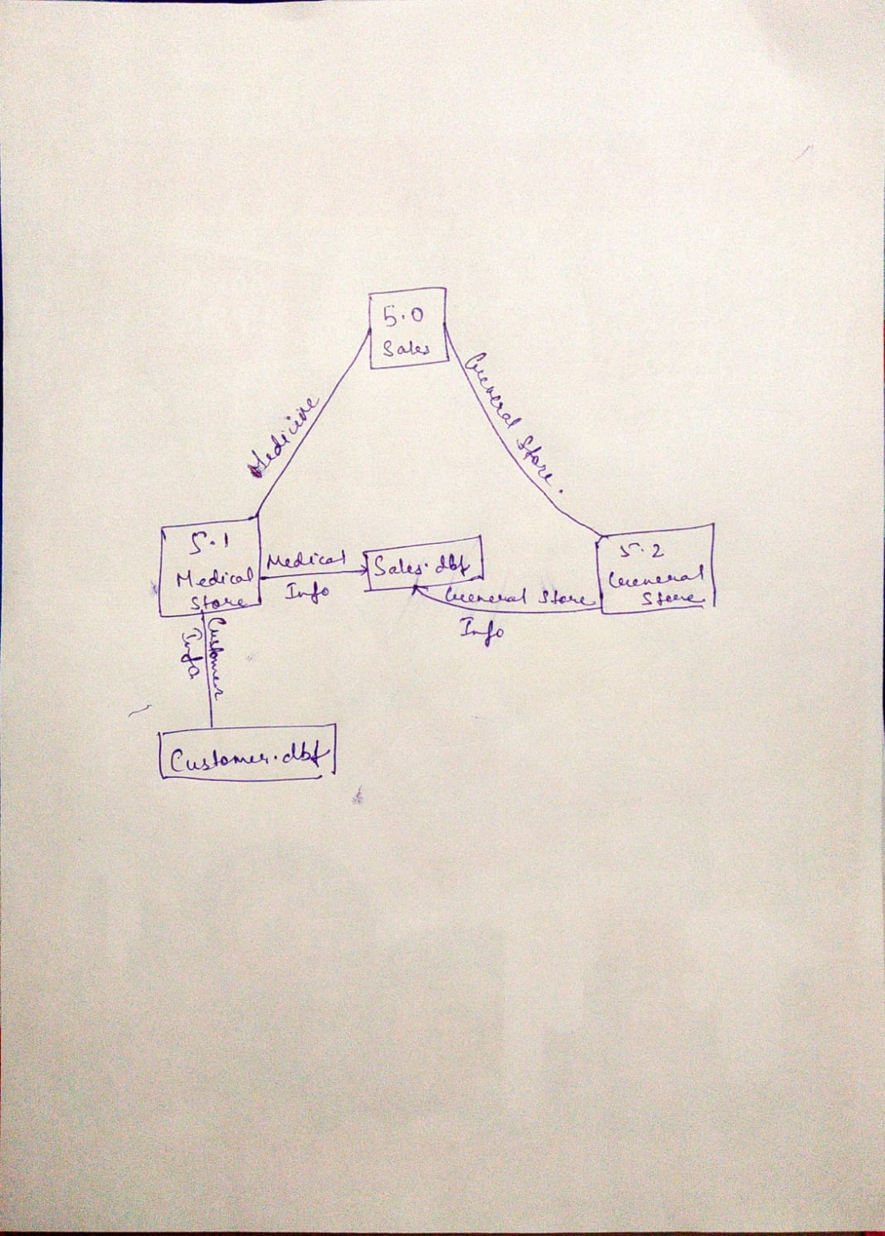

**Fig. 2nd Level DFD**

Further in the second level DFD the process 5.0 i.e. sales process is elaborated.

In the sale process, after selecting the mode i.e. medicine or general store the further operation is performed. The 5.1 process is the Medicine sale process in this process the patient’s information can be retrieved from the patient Database. If the patient is visiting for the first time than his information or detail is entered in the patient database.

Similarly the Doctor’s information or detail is also entered in the Doctor Database, who referred to the patient. If the patient is referred by the new Doctor than his information can be entered in the doctor’s Database.

With the help of the medicine sales process the patient’s and Doctor’ information can be entered or retrieved from the respective Database.

If the medicine or general store product has to be sold the information is retrieved from the sales database.